

**BUJUMBURA INTERNATIONAL UNIVERSITY**

Excellence in Education for Development

(O.M. NO. 610/136, 03 FEV. 2014)

Course: Mobile Application Development

**Project Topic : Food Ordering and Delivery Android App**

**By GROUP 5**

**Aimable MUNYESHAKA : 06-157**

**Florian NGABONZIZA : 06-082**

**Yvan NIHEZAGIRE : 06-232**

**For MSc Amédée KWIZERIMANA**

Table of Contents

Project Topic

ABSTRACT

CHAPTER 1 – INTRODUCTION

1.1 System Specifications

CHAPTER 2 – LITERATURE REVIEW

CHAPTER 3 OVERALL DESCRIPTION OF THE PROPOSED SYSTEM

3.1 Module Description

CHAPTER 4 – DESIGN

4.1UML Diagrams:

**4.1.1 Usecase Diagram**

**4.1.2 Sequence Diagram**

**4.1.3 Class Diagram**

**4.1.4 Activity Design**

CHAPTER 5 - OUTPUT SCREENSHOTS

CHAPTER 6 – IMPLEMENTATION DETAILS

CHAPTER 8 - TECHNICAL FEASIBILITY

CHAPTER 9 - SYSTEM TESTING

CHAPTER 10 – CONCLUSIONS

CHAPTER 11- REFERENCES

**Project Topic**

Food Ordering and Delivery Android App.

**ABSTRACT**

An Online Food Ordering System is proposed here which simplifies the food ordering process. The proposed system shows an user interface and update the menu with all available options so that it eases the customer work. Customer can choose more than one item to make an order and can view order details before logging off. The order confirmation is sent to the customer. The order is placed in the queue and updated in the database and returned in real time. This system assists the staff to go through the orders in real time and process it efficiently with minimal errors.

**CHAPTER 1 – INTRODUCTION**

System Specifications

The labour rates are increasing steadily year on year thus making it difficult to find employees. The food industry is highly labour intensive and the biggest expense in the food industry is the cost of employing the right kind of people to do the work. One of the ways to reduce this expense is to use modern technology to replace some of the jobs done by human beings and make machines do the work. Here we propose an “Online Food Ordering System” that has been designed for Fast Food restaurant, Take-Out or College Cafeterias. The system can also be used in any food delivery industry. This simplifie the process of food ordering for both the customer and the restaurant, as the entire process of taking orders is automated.

**CHAPTER 2 – LITERATURE REVIEW**

2.1 Existing Food Order Process

2.1.1 Full service restaurent :

Tradition food order process used in most full-service restaurants starting when a waiter brought the guests the paper-based menu, and then waiting for the guests to choose items from the menu and inform the waiter the order items. The process typically required the guests to be seated in the restaurant and a waiter to assist the ordering. One of the most widely used food ordering system is the conventional paper based system. In this system all records are stored on paper. The main drawback of this system is papers can get easily lost or damaged. There is also wastage of money, time and paper. Paper-based systems do not provide any form of dynamicity. Even a small change requires the re-print of entire menu-card. Also large amount of human efforts are required, this system is not work properly because it has some error and from a customer’s point of view it is time consuming.

**2.1.2 Self-service restaurent :**

This process required the guests to place order at the service counter in the restaurant. The guests shall have decision in advance, before presented at the counter, of which menu items to order. Menu catalog is mostly presented as posters placing behind the order counter.

**2.1.3 Automated food ordering system :**

In order to reduce service cost and enhance customer experiences, few restaurants have invested in the service automation system. The automation system used to capture the food order from guests ranged in many forms but mostly comprise of an electronic of conductive material. One more disadvantage of capacitive touch screen is it is expensive, offers less durability and short life. The drawbacks of resistive touch screen include its inability to support multi-touch gestures, its poor visibility in direct sunlight and its less durability. The technology can be susceptible to data-noise, it may be affected by large amounts of dirt and dust in the environment.

**CHAPTER 3 OVERALL DESCRIPTION OF THE PROPOSED SYSTEM**

3.1 Module Description

The restaurant owner or manager will have authority to log into the system and update the menu as per the availability of the food. Manager will dynamically add different categories of food. After arrival of customer in restaurant, he or she select the information and menu from tablet or smart phone then this order sent to the system over internet. The restaurant manager or owner and the kitchen staff will receive the ordered lists from the customer phone or system after payment of customer. Restaurant will stack order and delivery to the customer.

**CHAPTER 4 – DESIGN**

4.1UML Diagrams:

UML is an acronym that stands for Unified Modeling Language. Simply put, UML is a modern approach to modeling and documenting software.

A UML diagram is a diagram based on the UML with the purpose of visually representing a system along with its main actors, roles, actions, artifacts or classes, in order to better understand, alter, maintain, or document information about the system.

**4.1.1 Usecase Diagram**

A use case diagram is a behavior diagram and visualizes the observable interactions between actors and the system under development. The diagram consists of the system, the related use cases and actors and relates these to each other: System: What is being described?

Actor: Who is using the system?

Use Case: What are the actors doing?

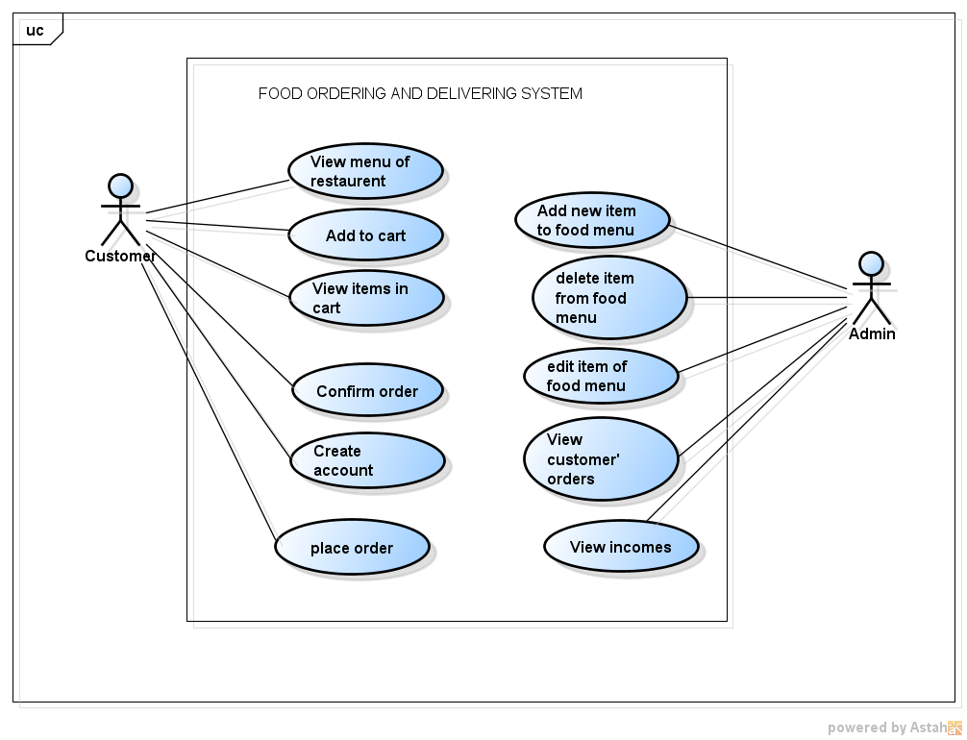

**4.1.2 Sequence Diagram**

A sequence diagram is a type of interaction diagram because it describes how and in what order a group of objects works together. These diagrams are used by software developers and business professionals to understand requirements for a new system or to document an existing process.

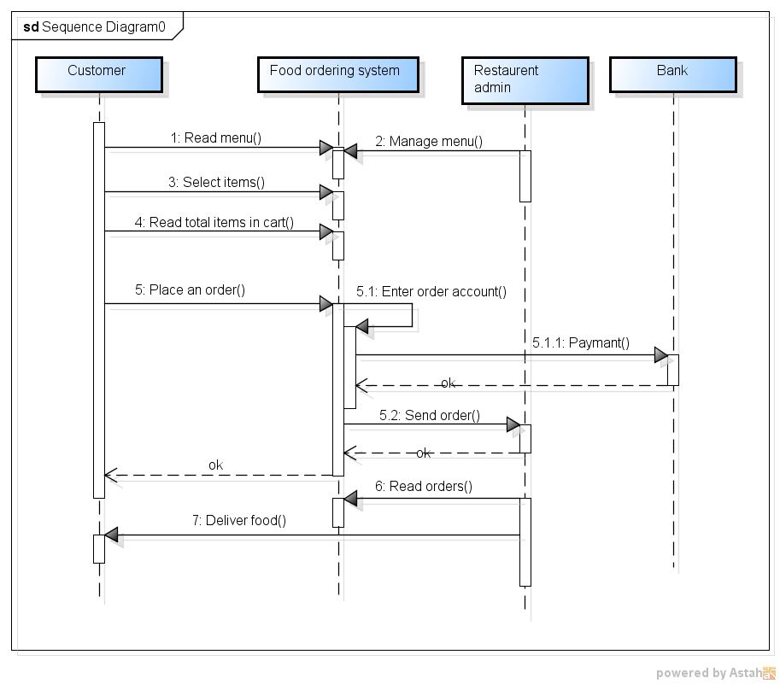

**4.1.3 Class Diagram**

A class diagram is an illustration of the relationships and source code dependencies among classes in the Unified Modeling Language (UML). In this context, a class defines the methods and variables in an object, which is a specific entity in a program or the unit of code representing that entity.

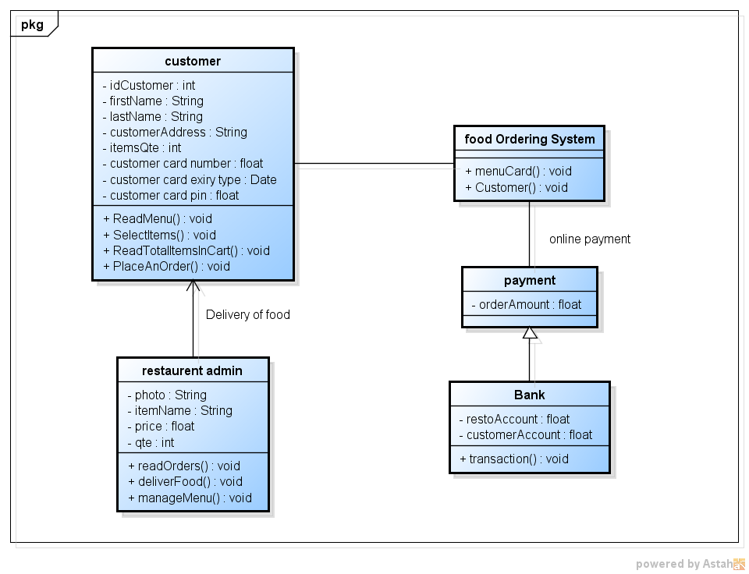

**4.1.4 Activity Design**

An activity diagram is a behavioral diagram i.e. it depicts the behavior of a system. An activity diagram portrays the control flow from a start point to a finish point showing the various decision paths that exist while the activity is being executed.

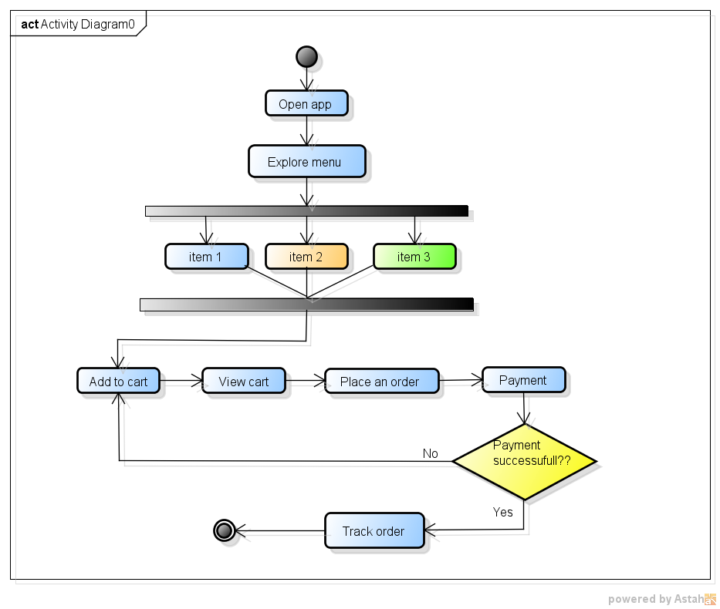

**CHAPTER 5 - OUTPUT SCREENSHOTS**

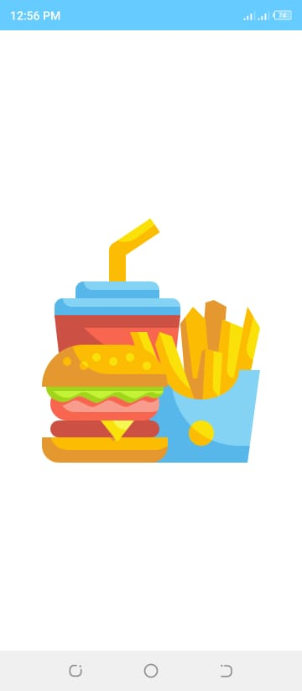

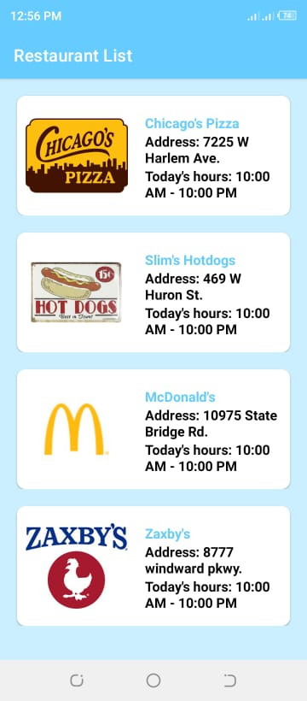

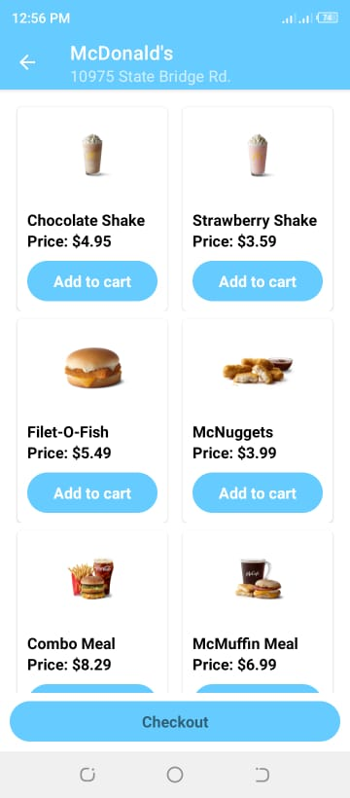

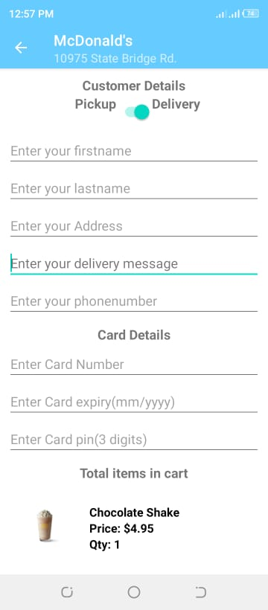

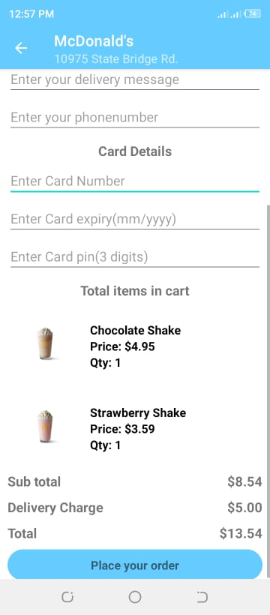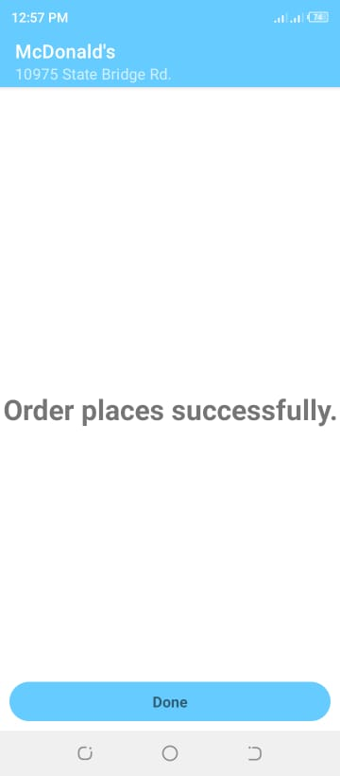

**CHAPTER 6 – IMPLEMENTATION DETAILS**

This application is going to use android studio as IDE (Integrated Development Environment), Java as programming languge. The structure of the application will consist of a backend and a frontend. The backend will be implemented using firebase, its purpose is to handle database queries, authentication. The frontend should be completed using xml.

**CHAPTER 8 - TECHNICAL FEASIBILITY**

The feasibility study is an important phase during the development of any project, its goal is to determine whether the project is doable or not. My capstone project is about building an android application, which purpose is to help people in choosing their favourite food from restaurant, and place an order,pay and restaurent delivery the food the customer. First, the technical feasibility is to understand if it is possible to complete the project with the current technologies. This application is going to use android studio as IDE (Integrated Development Environment), Java : programming languge, firebase : its purpose is to handle database queries, authentication and xml for frontend.

This application can be monetized using different plans. The first one consists of displaying advertisements to the android application by using services such as google adMob. The second technique is to get a commission for every order, which means that every time the user orders something from a restaurant, a small fee should be paid for the maintenance of the application.

**CHAPTER 9 - SYSTEM TESTING**

When android application developers are not completely done building up **he/she find problems early by unit testing and it facilitates Change, Simplifies Integration.** When he/she are completely done building up their versatile application, it’s possible that they are on edge and anxious to dispatch the item to the client. He/she has to do the integration testing : before the dispatch of an application, it is shrewd to check whether the application is capable in performing crucial capacities, for example, downloading and execution, functional testing, usability testing, compatibility testing, security testing for transaction.

**CHAPTER 10 – CONCLUSIONS**

The restaurant owner or manager have authority to log into the system and update the menu as per the availability of the food. Manager dynamically add different categories of food. After arrival of customer in restaurant, he/she selects the information and menu from tablet or smart phone then this order sent to the system. The restaurant manager or owner and the kitchen staff will receive the ordered lists from the customer phone or system after payment of customer. Restaurant will stack order and delivery to the customer.

**CHAPTER 11- REFERENCES**

* IJRTE (July 2019) how to make abstract and introduction : <https://www.ijrte.org/wp-content/uploads/papers/v8i2S3/B11560782S319.pdf> retrieved on 14th October, 2021
* Ijiset (4th April, 2015) how to make literature review : <http://ijiset.com/vol2/v2s4/IJISET_V2_I4_112.pdf> retrieved on 19th October, 2021